Git Bash tutorial:

To open your local repository: right click the file that contains the .git and then click git bash (not every university machine has git, so check when you loggin)

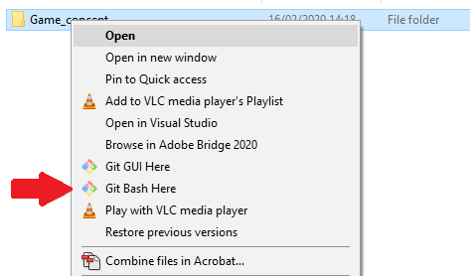

To check if your branch is up to date type git status, it will return the data of each branch:

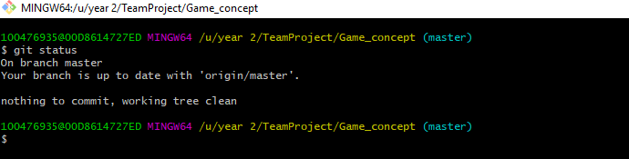

To add any changes to the commit you wish to make use “git add <filename>”

To make a commit to your local branch use git commit -m “comment here”:

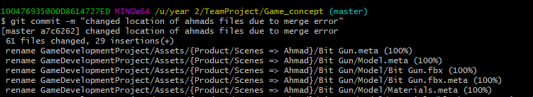

FOR BRANCH OWNER: to push a commit to the master use:

“git push <https://github.com/jdouglas7122a/Game_concept.git>”

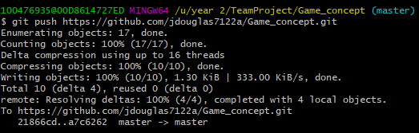

To find the address of your fork use “git remote show origin”:

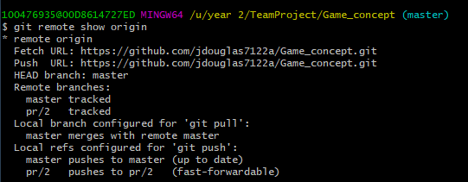

After you’ve staged added the changes, commited them and pushed the commit to your local fork, you then need to submit a pull request if your done. This is done by

Bash your local repository:

Then:

git fetch upstream

hit checkout master

git merge upstream/master

This will update your current fork to the current master.

To clone a repository to your local drive from git use:

git clone <https://github.com/jdouglas7122a/Game_concept>